Regional Growth Fund

Initial Application Form

Snapshots from GMS Portal

Contents
GMS Portal landing page 3
Registering / Logging In 5
Resetting your password 9
Manage Your Organisation and User Details 10
Change / confirm Organisation details 10
Manage Users 11
Commencing an Initial Application 13
Navigating the Initial Application Form 17
Before you Begin 18
Checklist 22
Applicant Details 23
Project Information 26
General Details 26
Mapping Tool 28
Project Location 29
Eligible Projects 31
Project Funding 32
Merit Criteria 35
Adding Attachments / Supporting Documentation 39
Legal Authorisation 43
Submit your Initial Application 47
Returning to a saved Initial Application 48
Submitting multiple Initial Applications 50
Contact 51

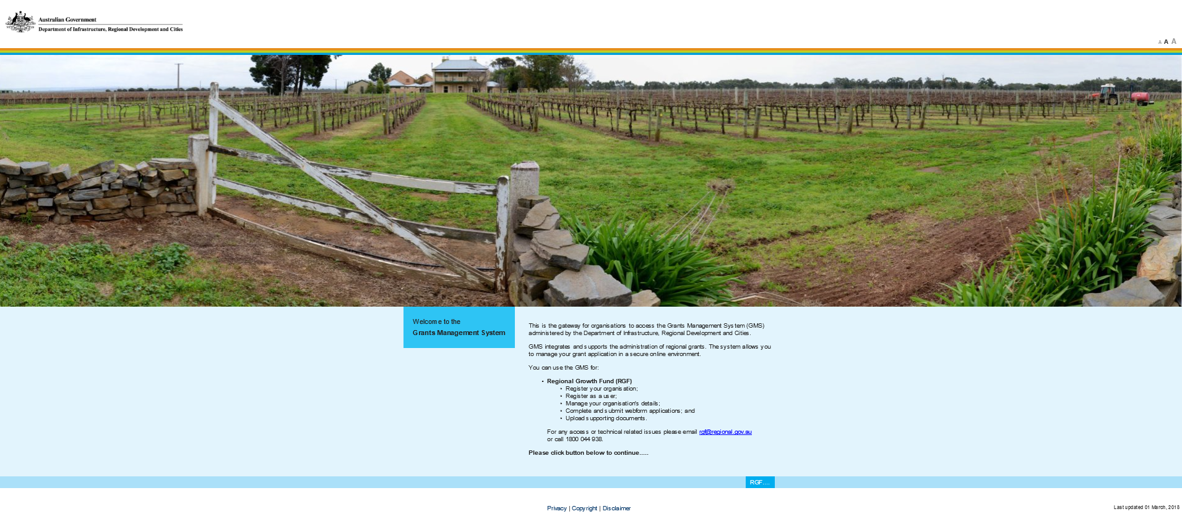

GMS Portal landing page

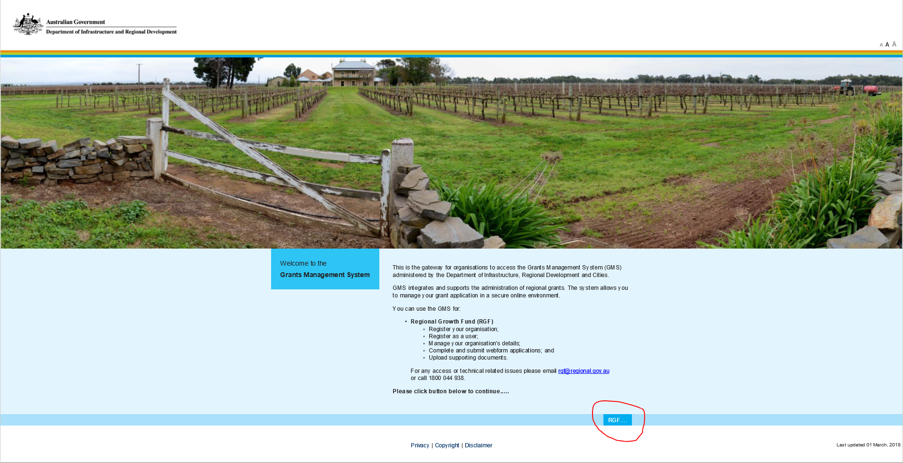

Select the RGF button to commence an application for “RGF”

Registering / Logging In

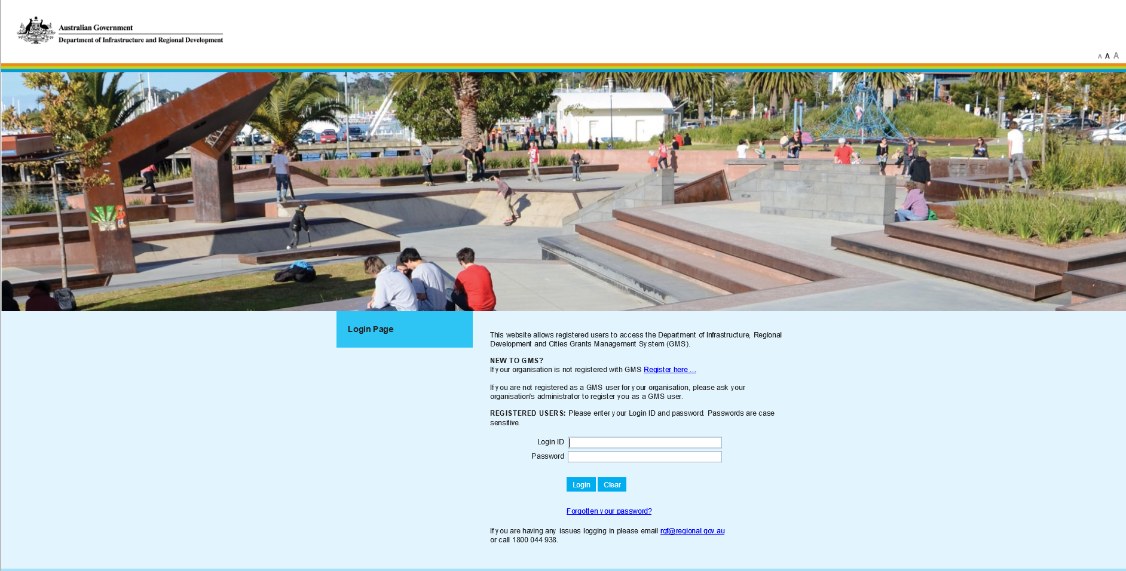
If your organisation is already registered and you can login using your login ID and password

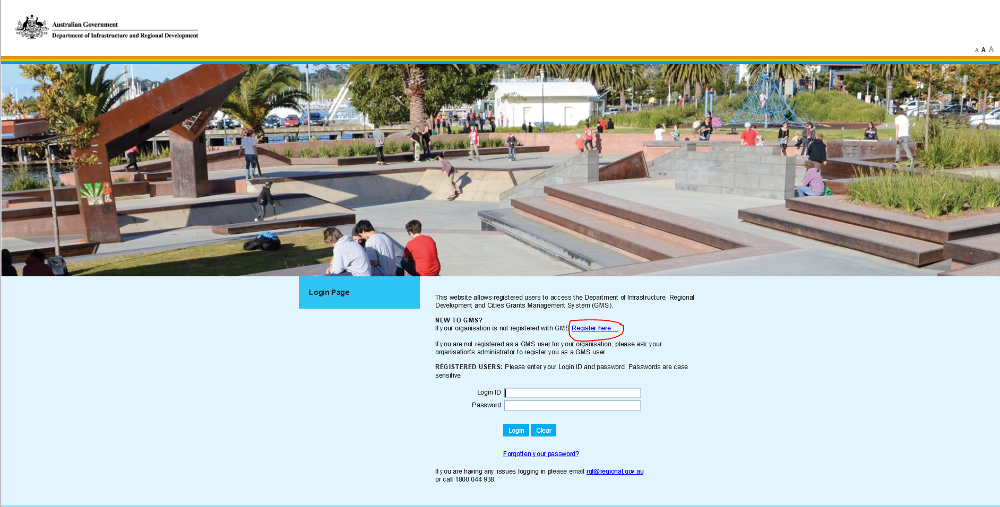
If your organisation is not registered or if you are unsure, select “Register here”.
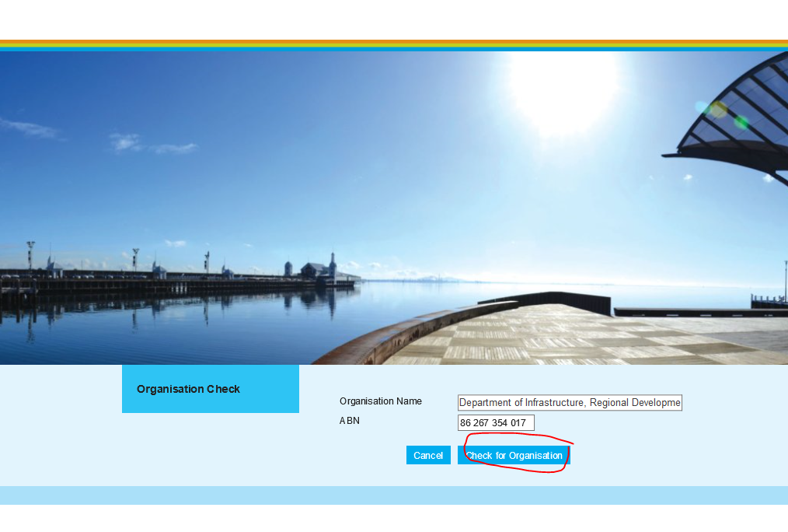
Enter your organisation details and ABN, and select “Check for Organisation”.
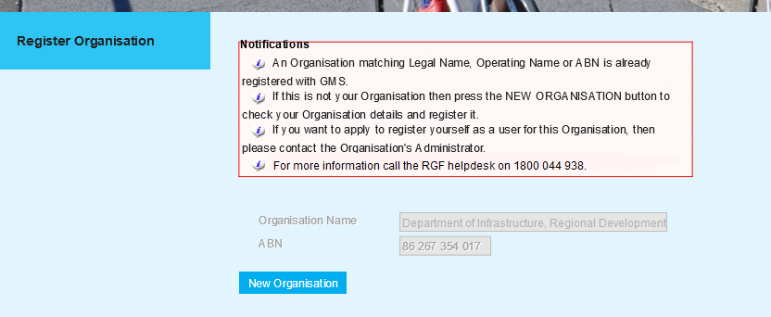

If your organisation name or ABN match an existing account, a message will appear
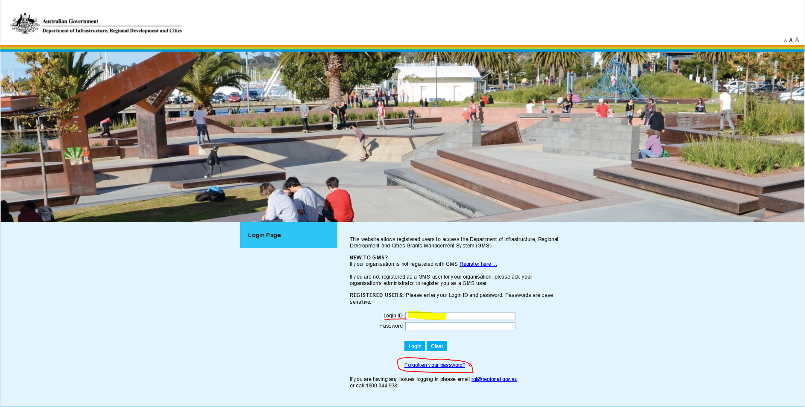
Resetting your password - If you have a Login ID but have forgotten your password, enter your login ID and select the “Forgotten your password?” button, and you will receive an email with a new password.

If you’re having trouble logging in, contact RGF help at rgf@regional.gov.au or by phone on 1800 044 938

Manage Your Organisation and User Details
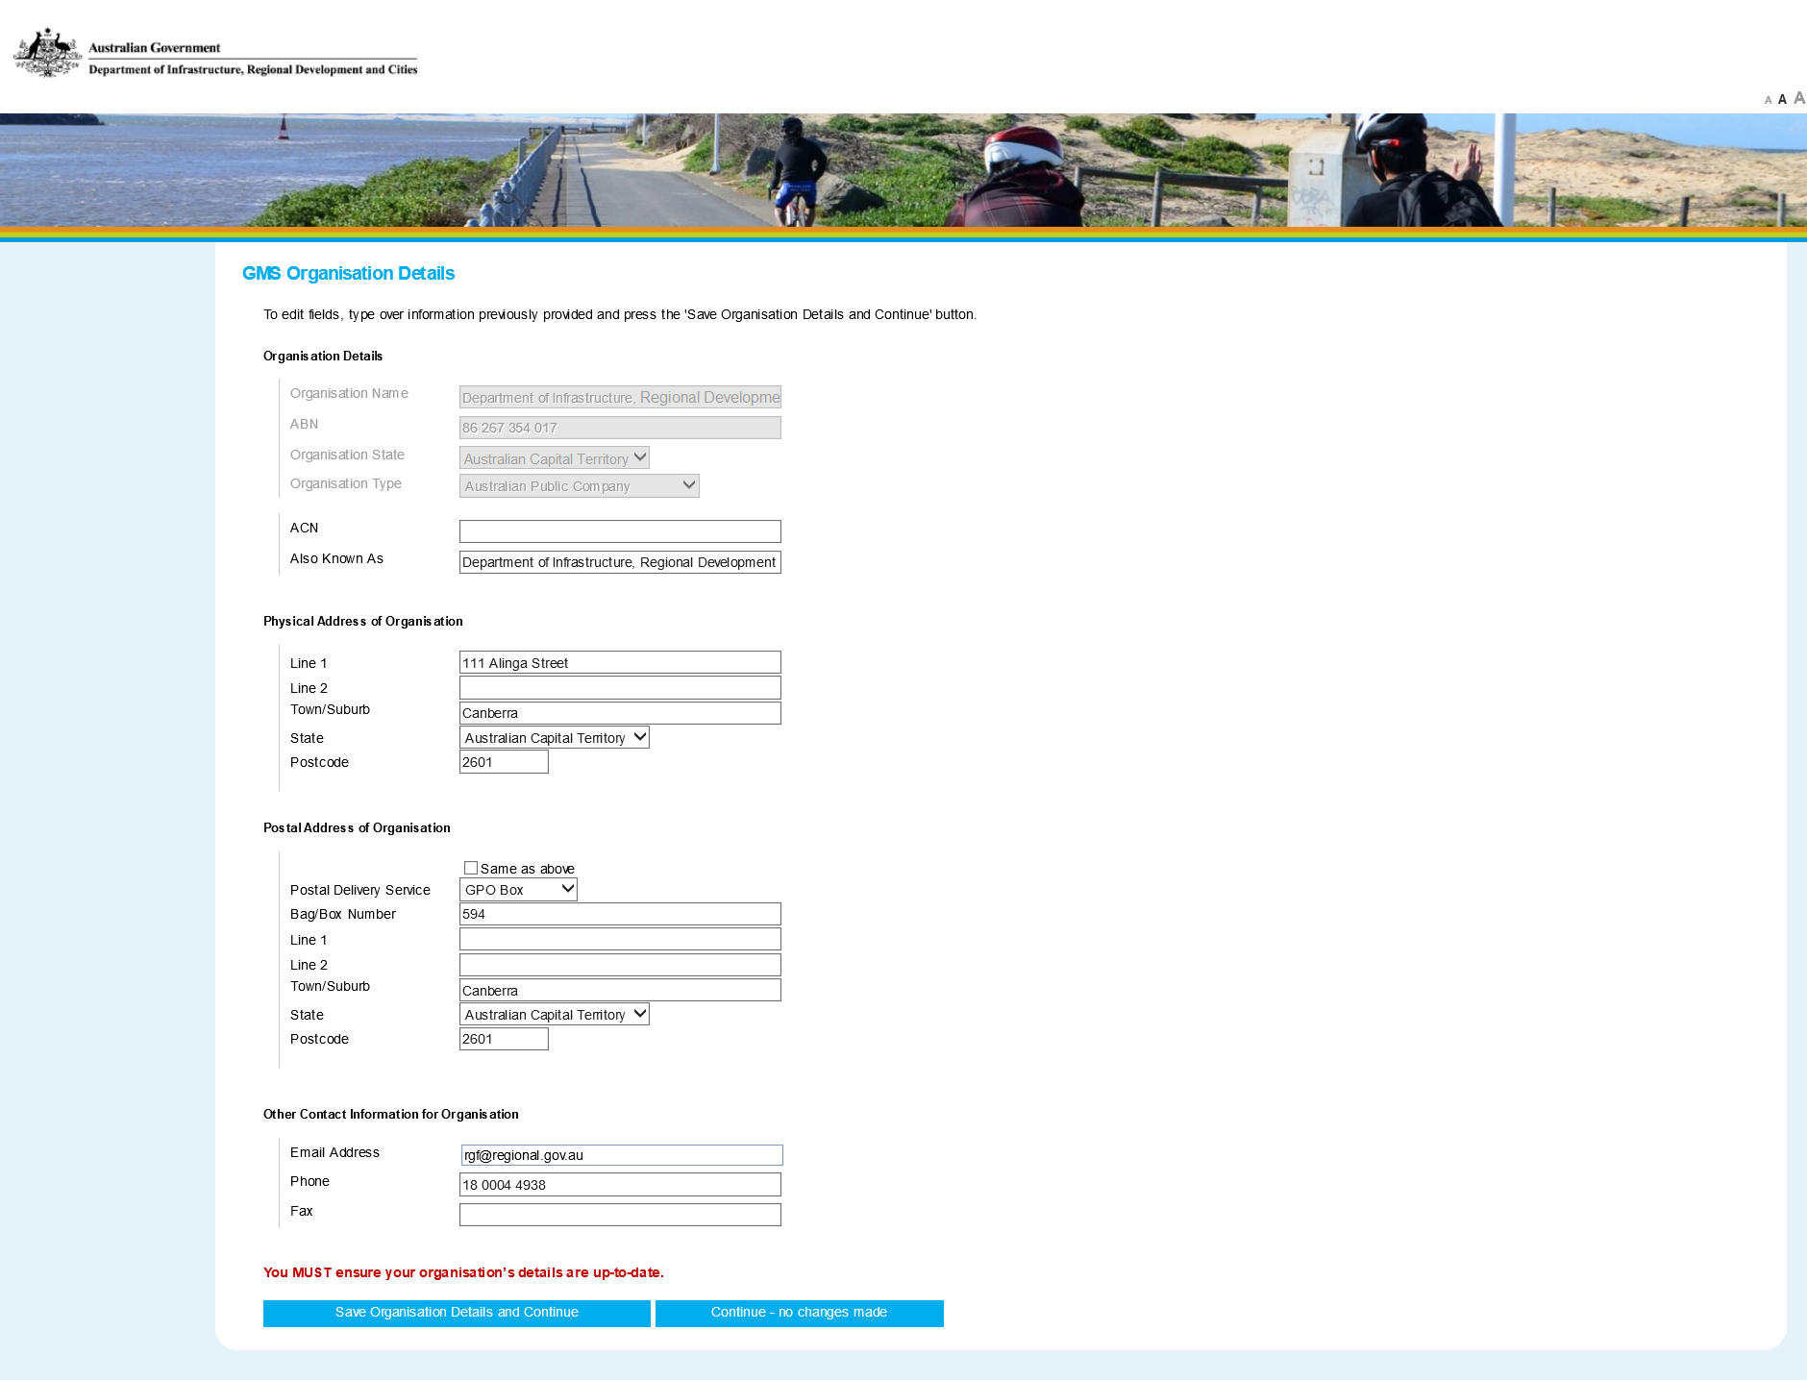
Change / confirm Organisation details - Once you have successfully logged in the initial screen will appear asking you to confirm your organisation details. If changes are required, make all necessary changes and select “Save Organisation Details and Continue”. If changes are not required, select “Continue – no change made”.

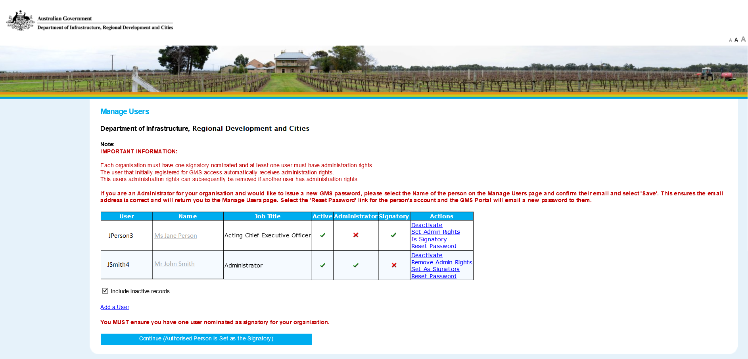
Manage Users - On the following page, you will be asked to manage users. Each Organisation must have one signatory nominated and at least one user must have administration rights. The Signatory should be someone with authorisation to submit an application on behalf of the organisation. The Signatory will be required to submit the application, once all fields are completed. Administration rights allow for the editing and creating of applications and updating of user and organisation details.
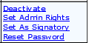
If you need to set someone as a signatory or provide administration rights, select the appropriate blue link next to their profile. You can also activate and deactivate someone’s account and reset their password.
Once you’re satisfied with the user account settings select the “Continue (Authorised Person is Set as the Signatory)” button.

Commencing an Initial Application
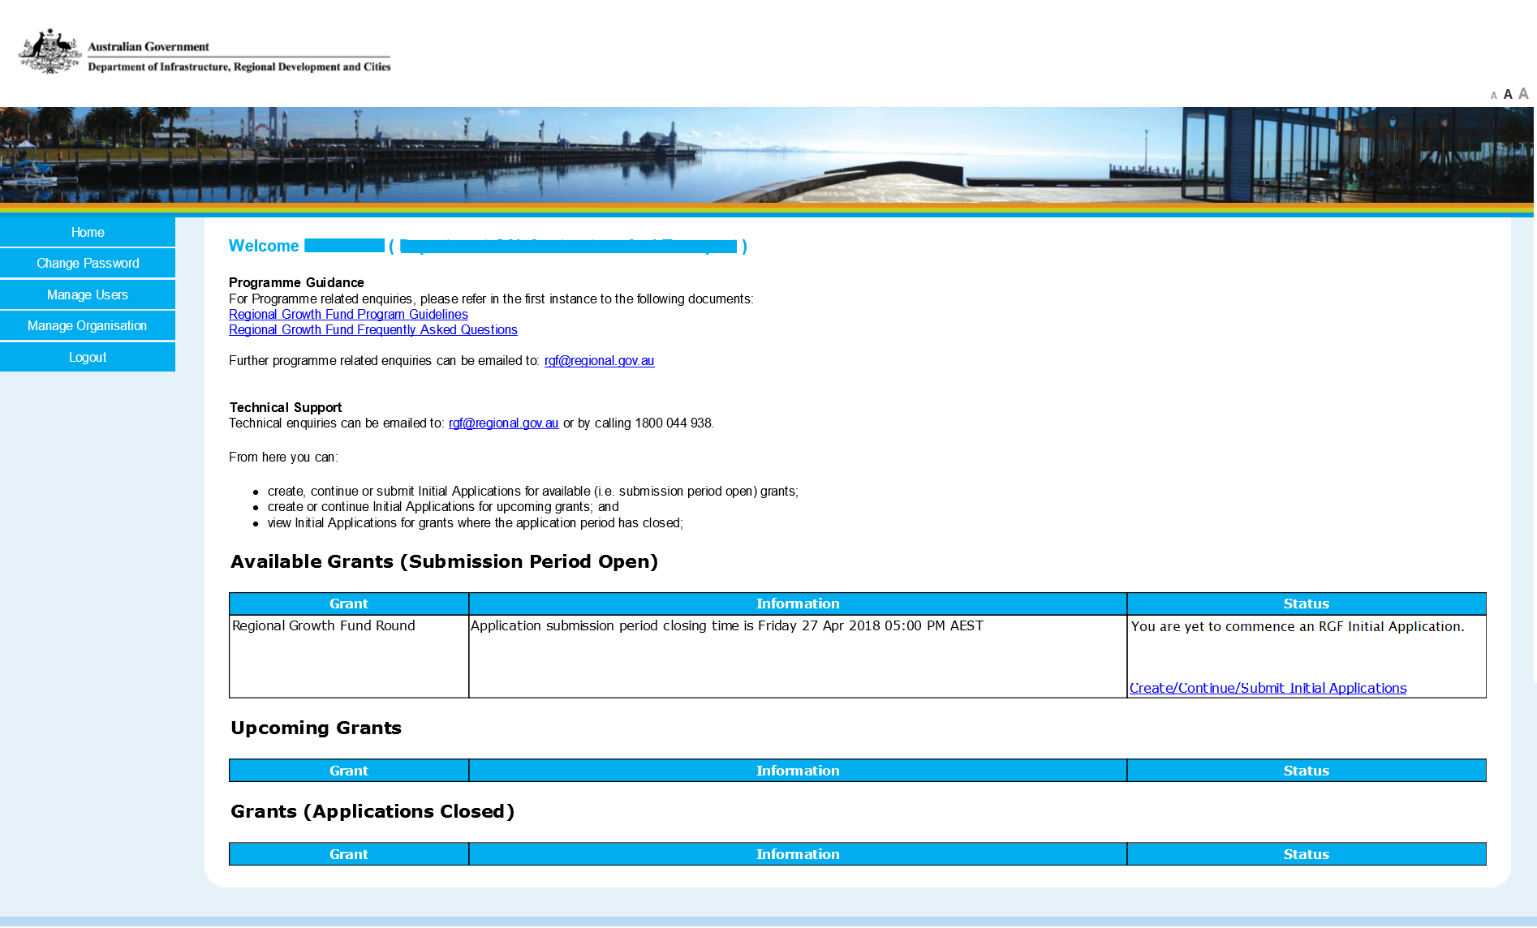
Once you have confirmed your Organisation and User details you will arrive at the Home Page.
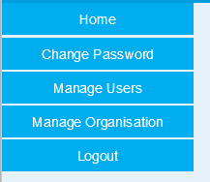
The menu bar on the left of screen will allow you to make updates to your organisation, users and reset password at any stage.
To create an Initial Application select “Create/Continue/Submit Initial Application”

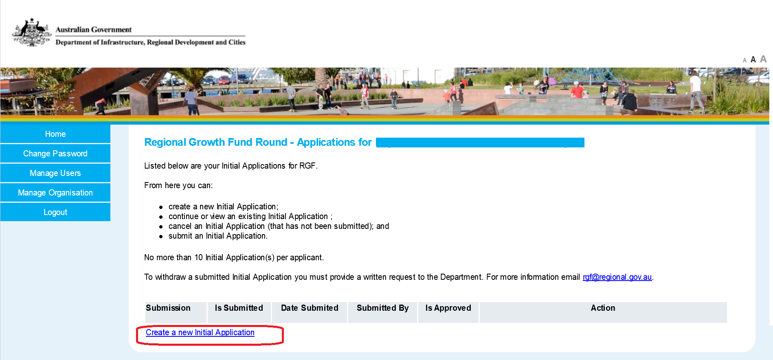
On the following screen, select “Create a new Initial Application”.

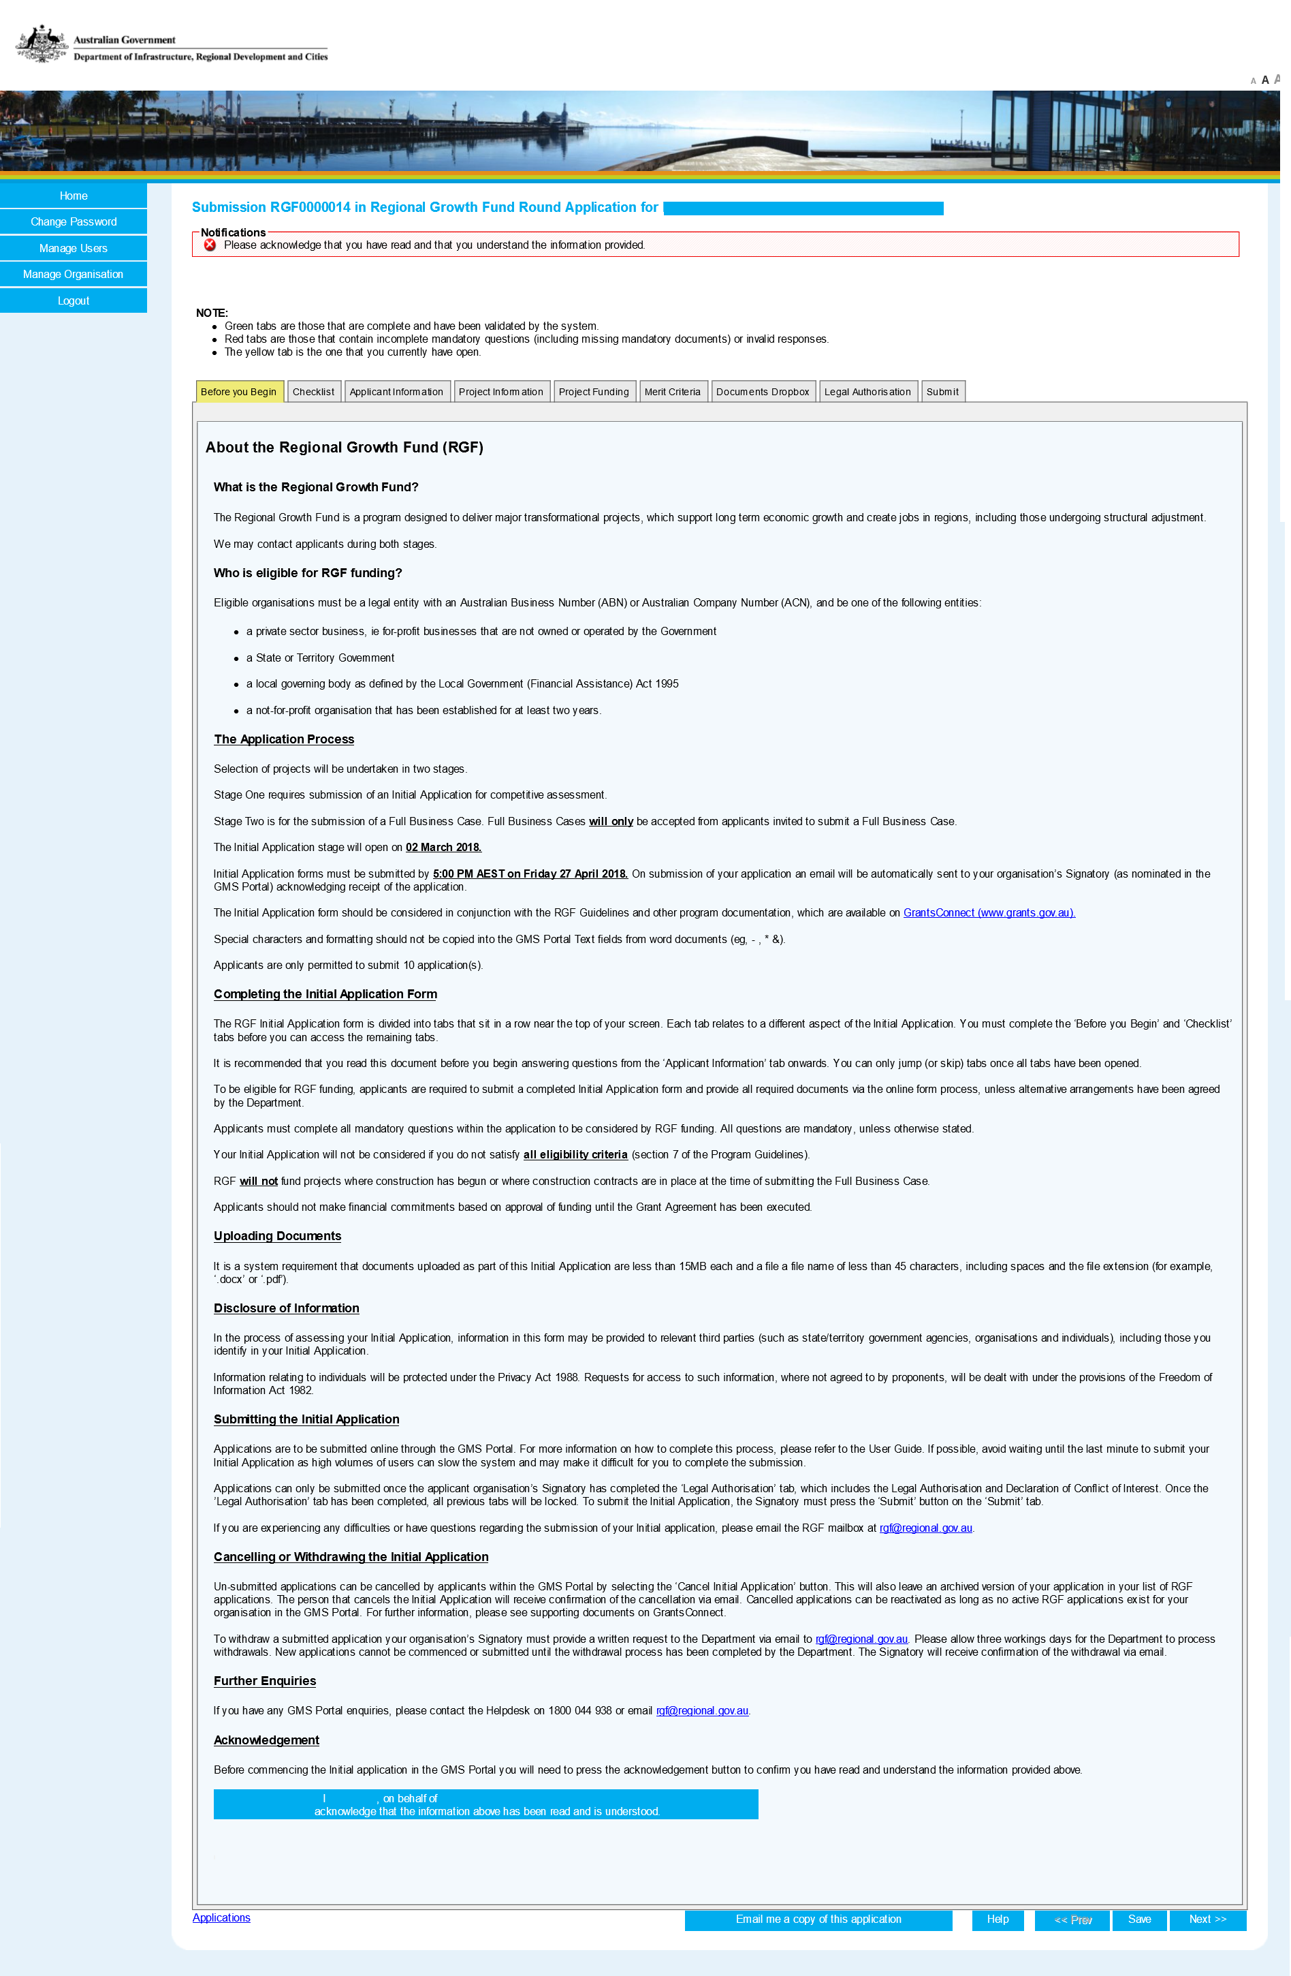
You will then be taken to the Initial Application form.

Navigating the Initial Application Form
The tabs across the top of the Initial Application form screen allow you to navigate to different sections of the Form. Completed sections (which have been validated by the system) will be shown in green, sections containing incomplete mandatory questions (including missing mandatory documents) or invalid responses red, and yellow for the tab is the one that you currently have open. Be sure to complete all necessary fields in your Initial Application before submitting.
The menu bar at the bottom allows you to trigger an email of your application to yourself, save progress and move back and to next. The help tab will take you to the Regional Growth Fund internet page where the Guidelines, Frequently Asked Questions and sample Agreement can be found. If completing your application in multiple sessions be sure to select save before logging out.

Before you Begin
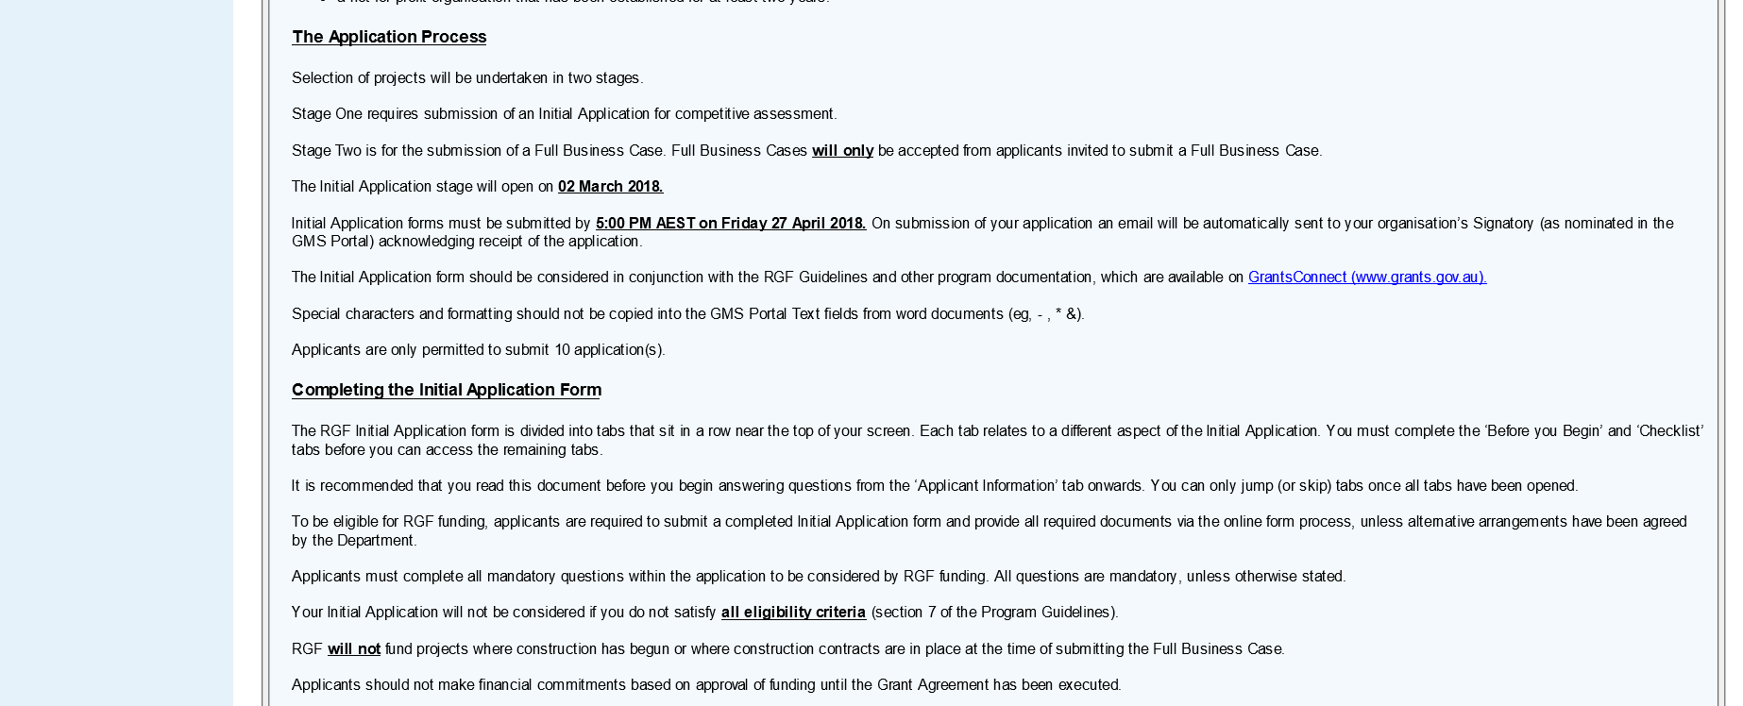
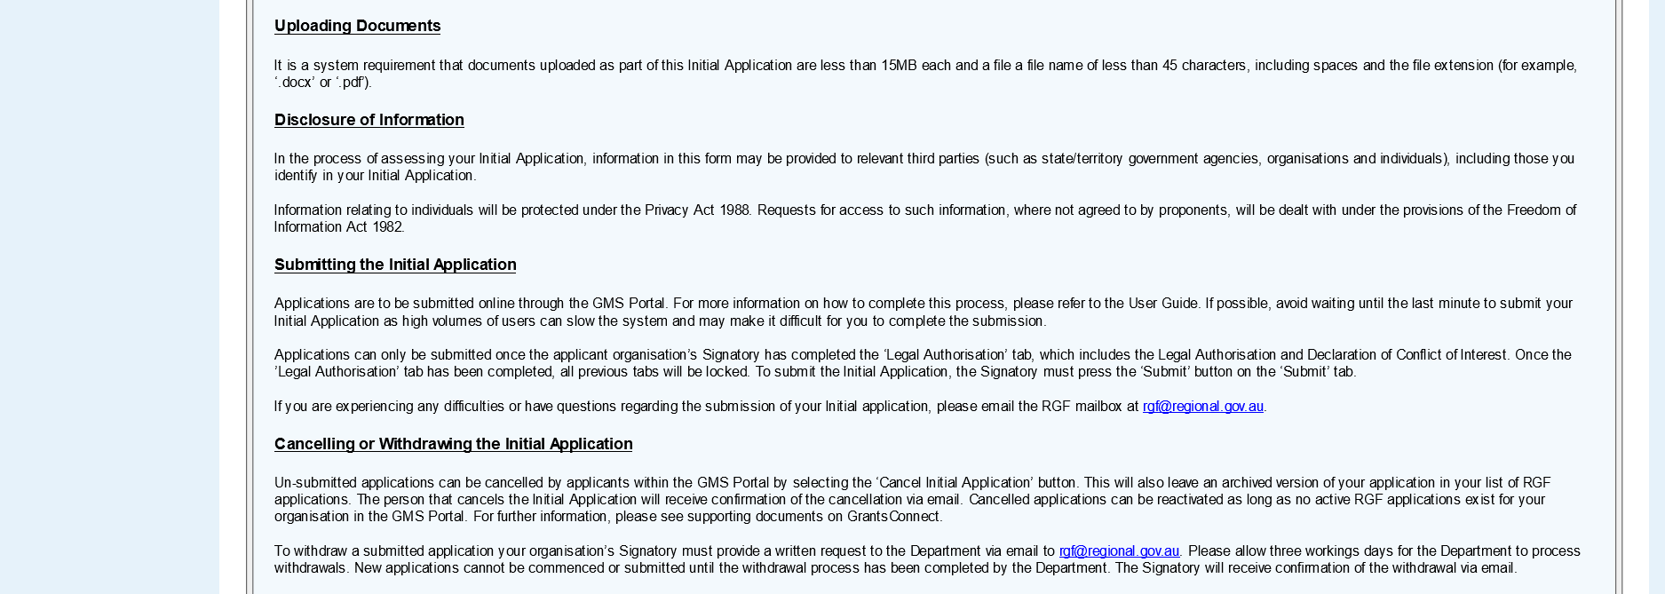
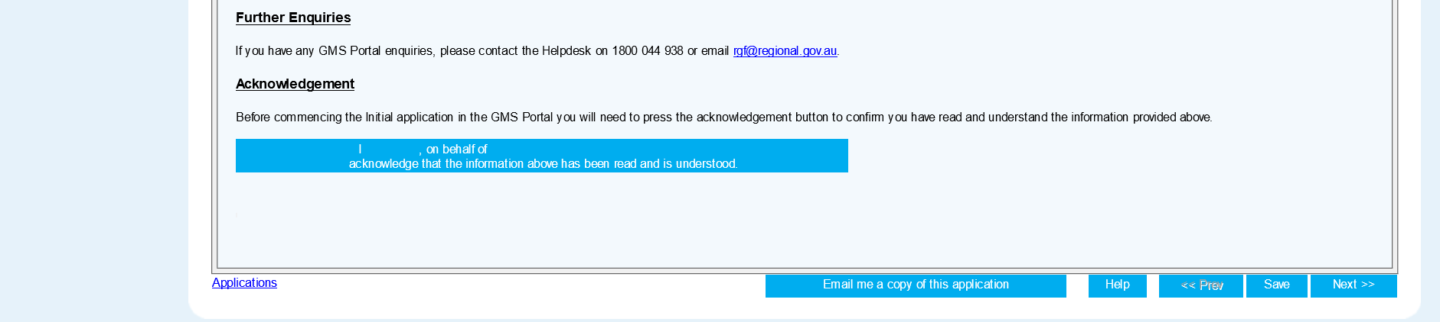
The first screen you will come to (Before your Begin tab) provides important background information. Be sure to familiarise yourself with this page, before selecting the button confirming you have read and understood.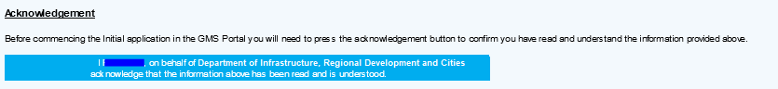

Checklist
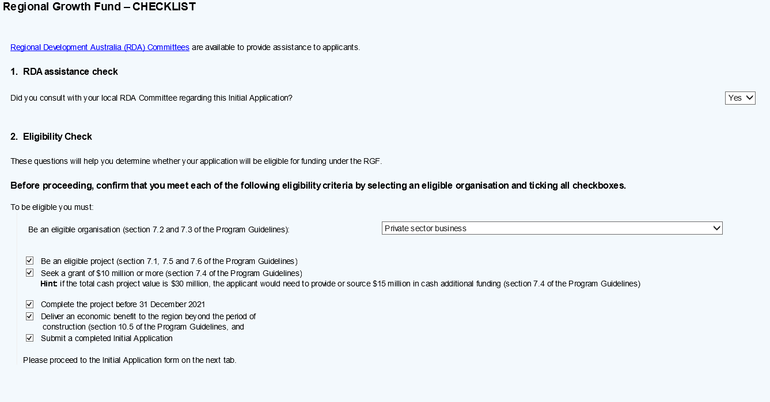

Applicant Details
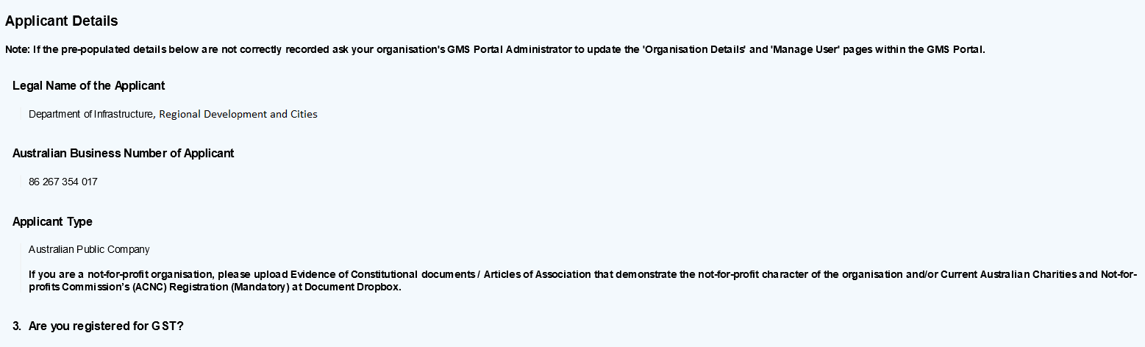
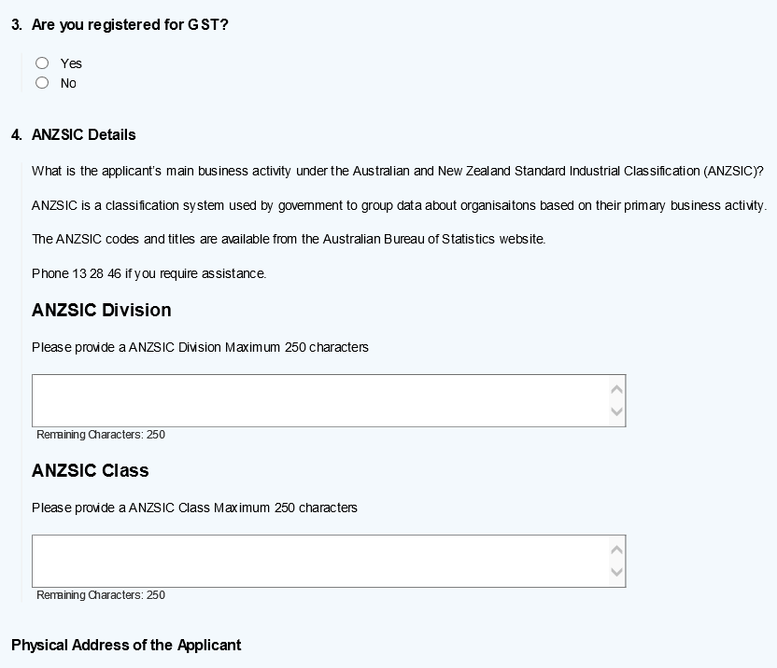
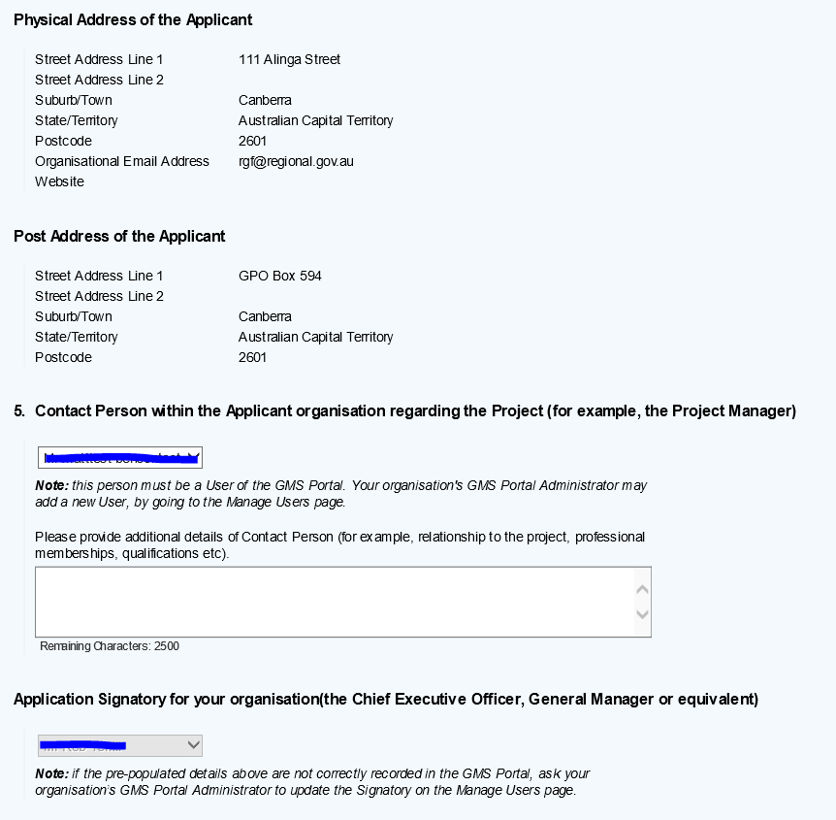

Project Information

General Details
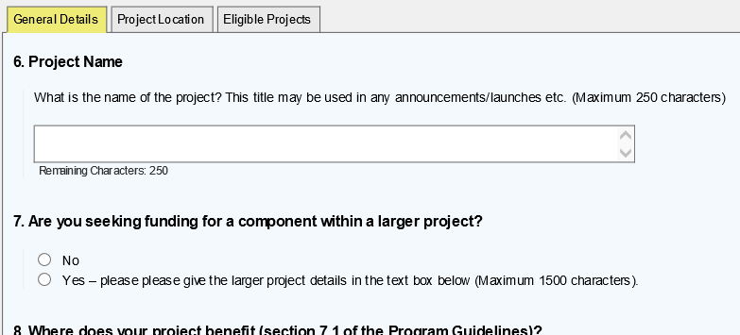

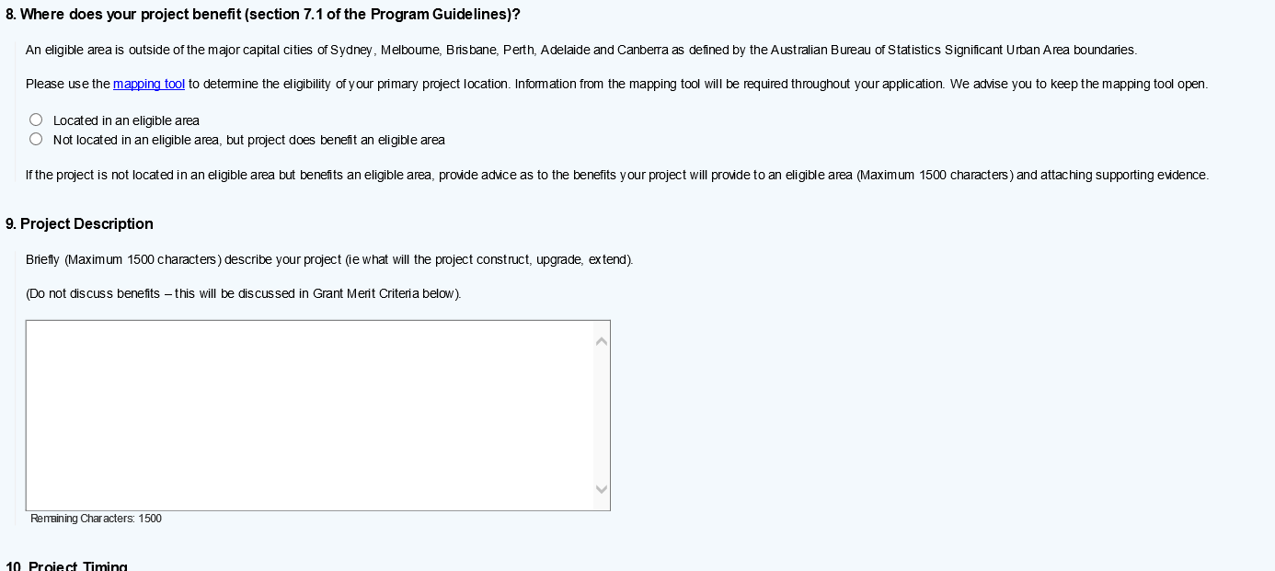
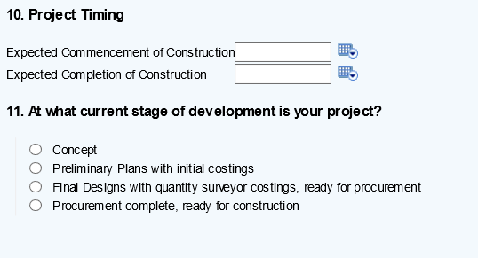

Mapping Tool
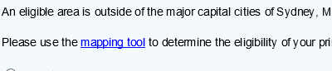
Throughout the Initial Application form, you’ll come across a hyperlink to the mapping tool. The mapping tool can be used to find details on project location eligibility and project coordinates. This will launch the mapping tool in your web browser.

Project Location
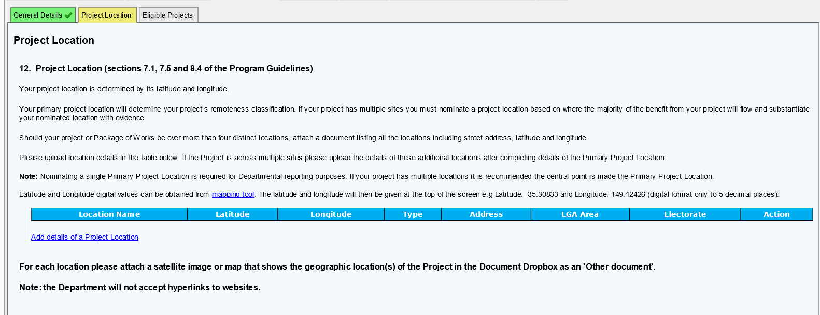
To enter your project location, select the “Add details of a Project Location” button. Multiple Project Locations can be added.
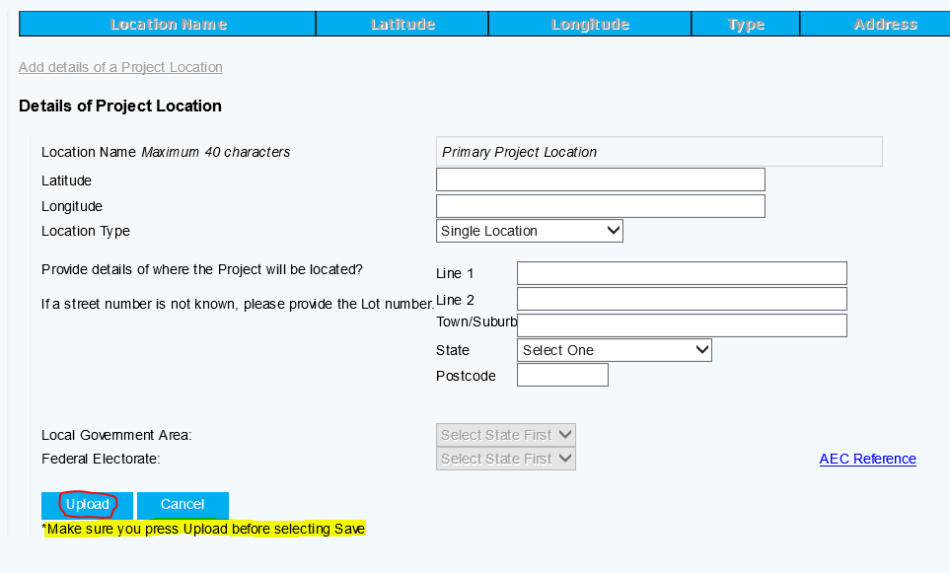
When adding your project location be sure to select the Upload button before selecting save or next, otherwise you will have to re-enter these details.

Eligible Projects
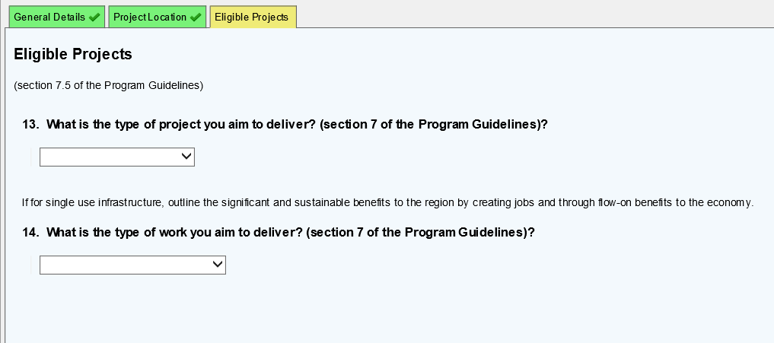

Project Funding
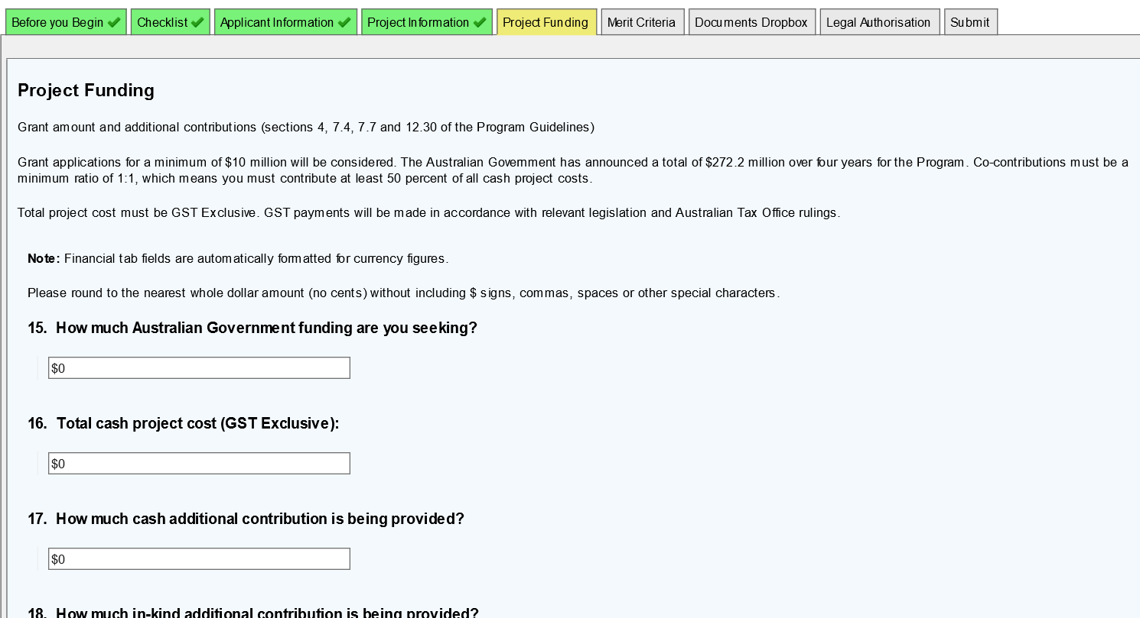

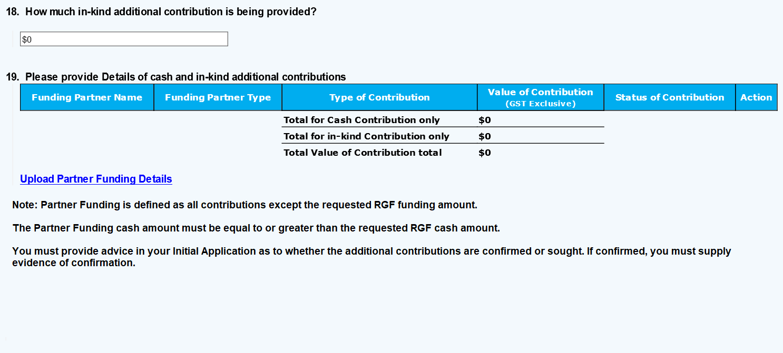
Details of other contributions can be entered by selecting “Upload Partner Funding Details”. Multiple Co-contribution Funding sources can be entered.
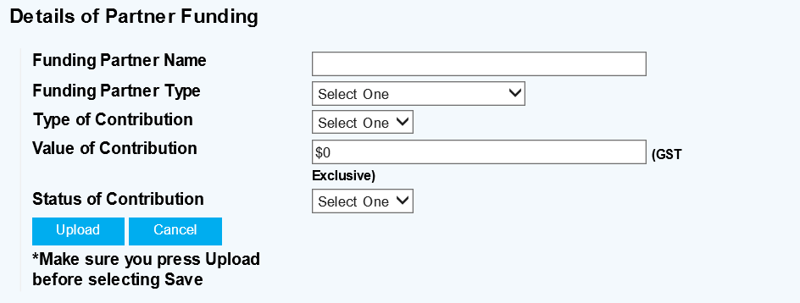
Be sure to select the Upload button before selecting save or next, otherwise you will have to re-enter these details

Merit Criteria
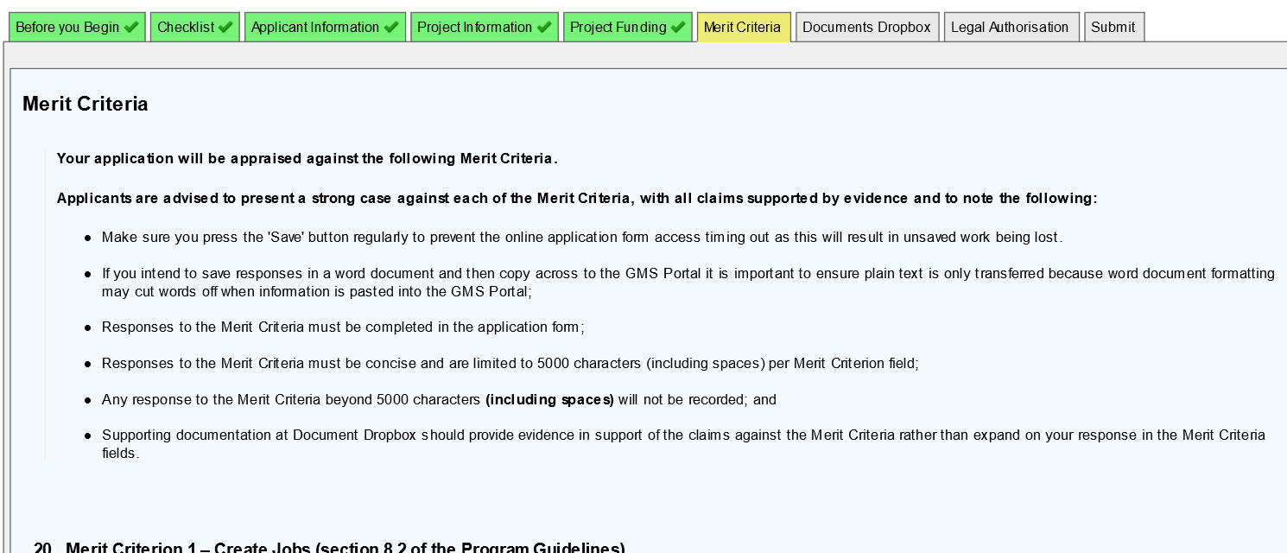

Be sure to address all Merit Criteria.
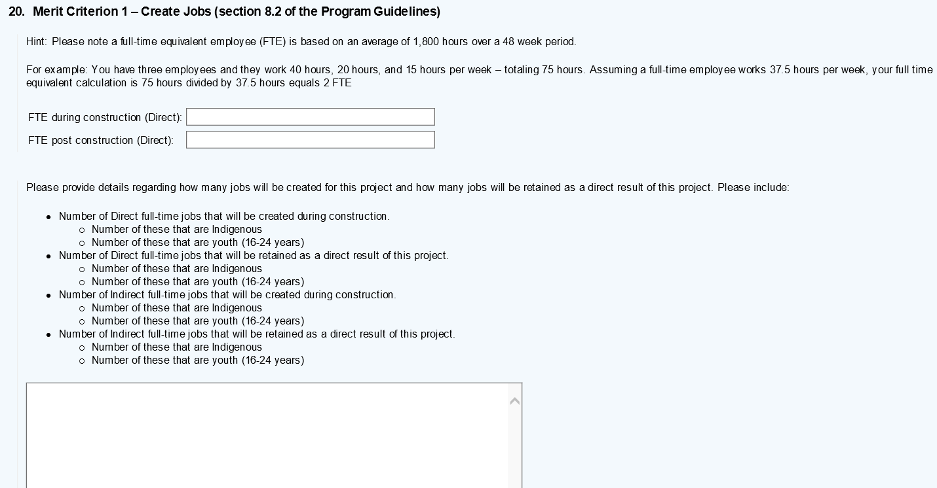

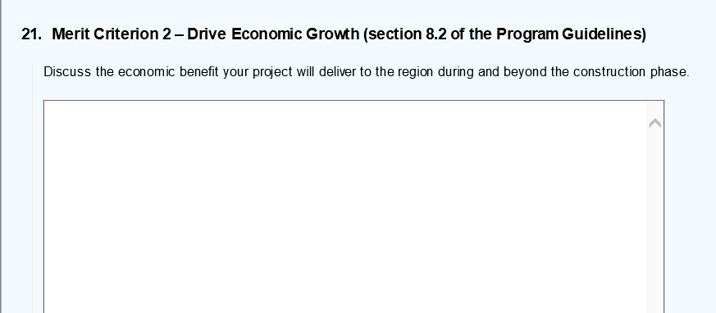

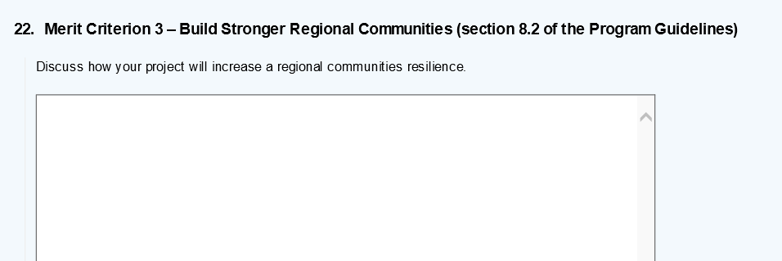

Adding Attachments / Supporting Documentation
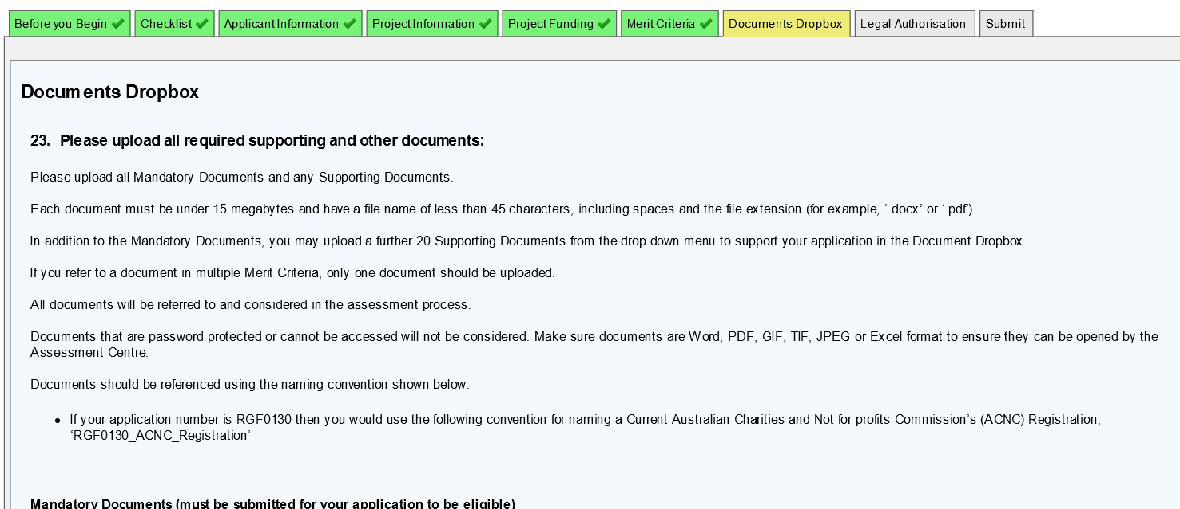
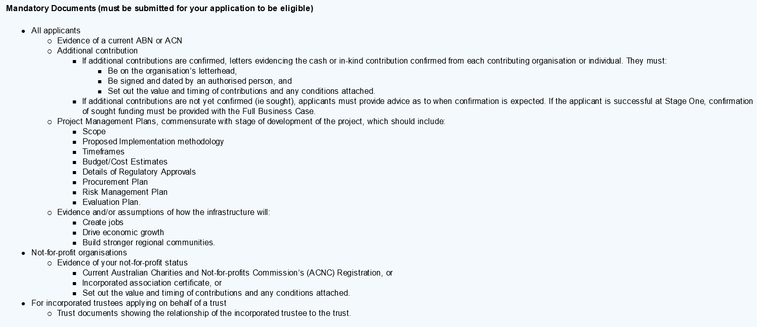
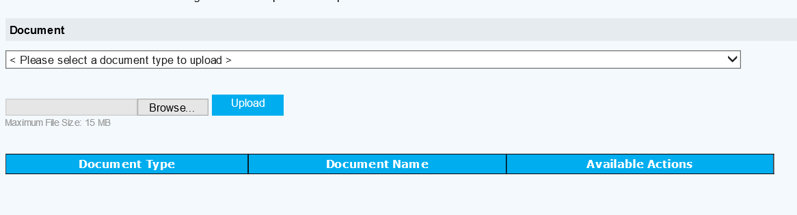
When Uploading Supporting documents, select the document type…
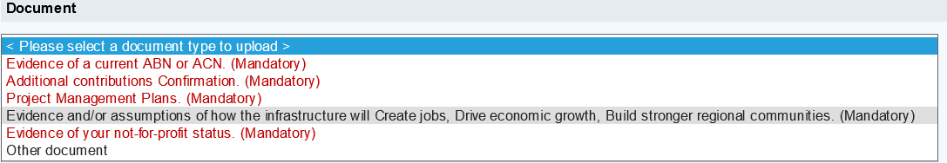
A drop down menu will appear…
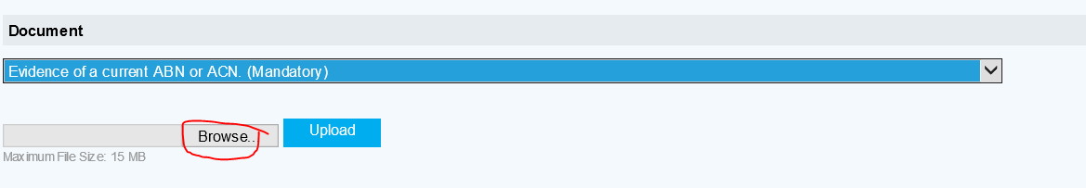
Select the Appropriate title from the drop down menu, select “Browse”, find your document and then press the “Upload” Button.
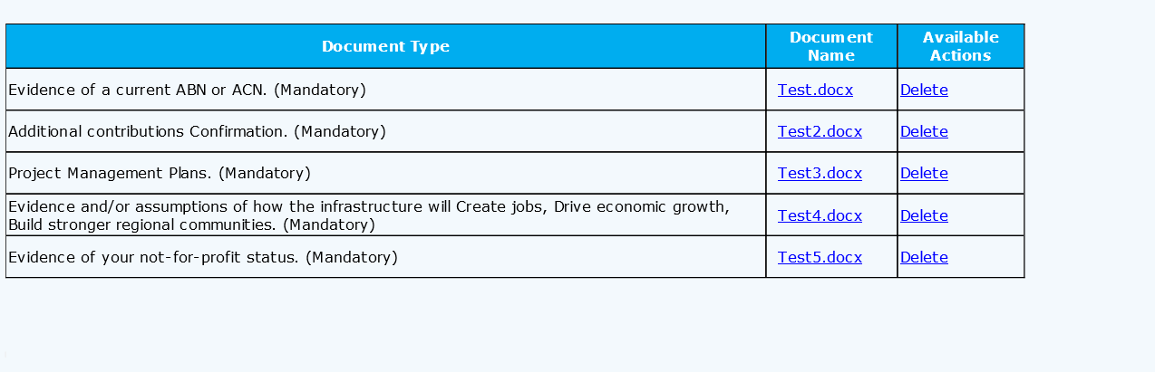
Attachments will need to be created for all mandatory documents. Uploaded documents will appear in a list below the upload field. If you have a mandatory attachment which consists of multiple documents, upload these under the “Other document” heading ensuring the document is clearly titled. You may upload as many “Other documents” as required.

Legal Authorisation
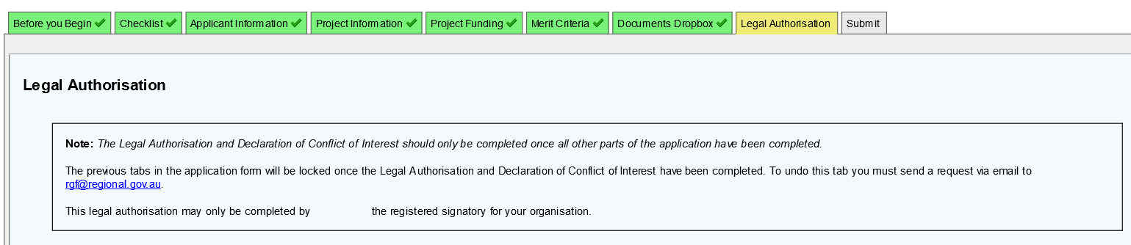
Please be sure to complete the legal authorisation. The checkboxes will act as an electronic signature.
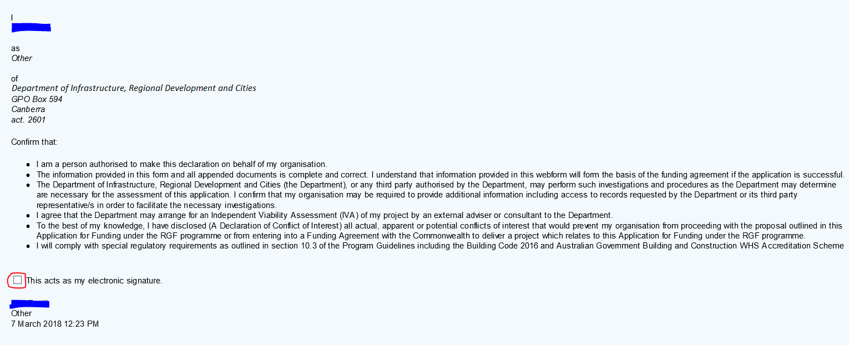

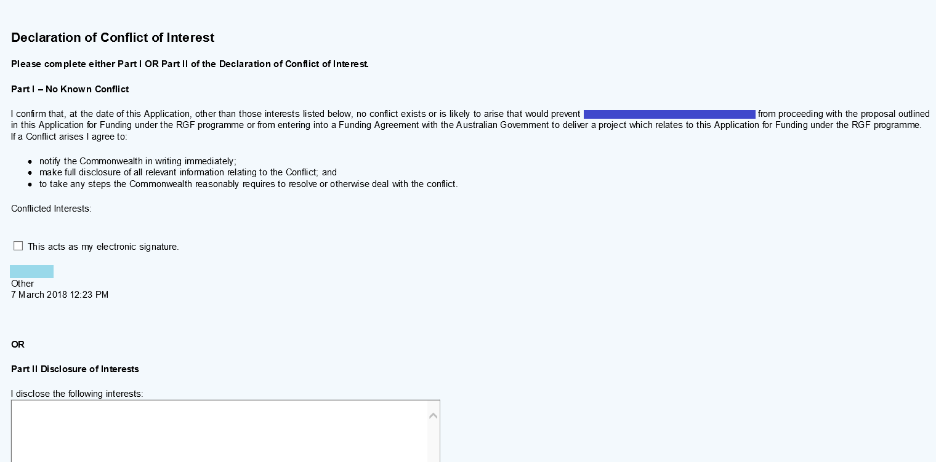
If you have a known conflict of interest, please disclose details of your interest in the free text field.
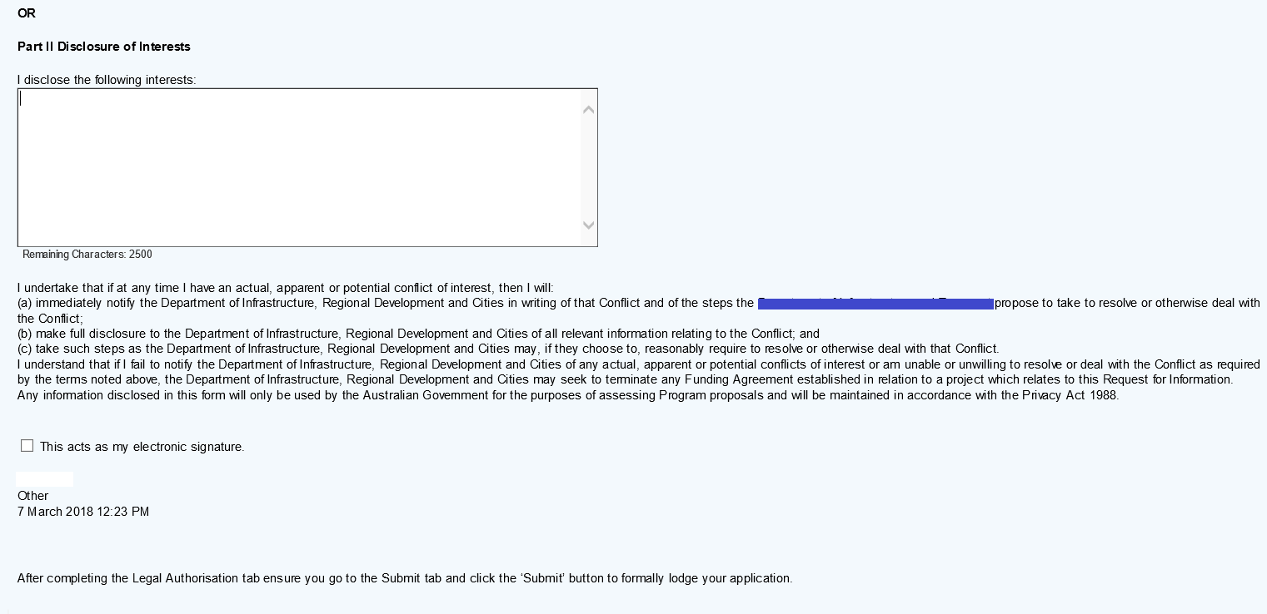

Submit your Initial Application
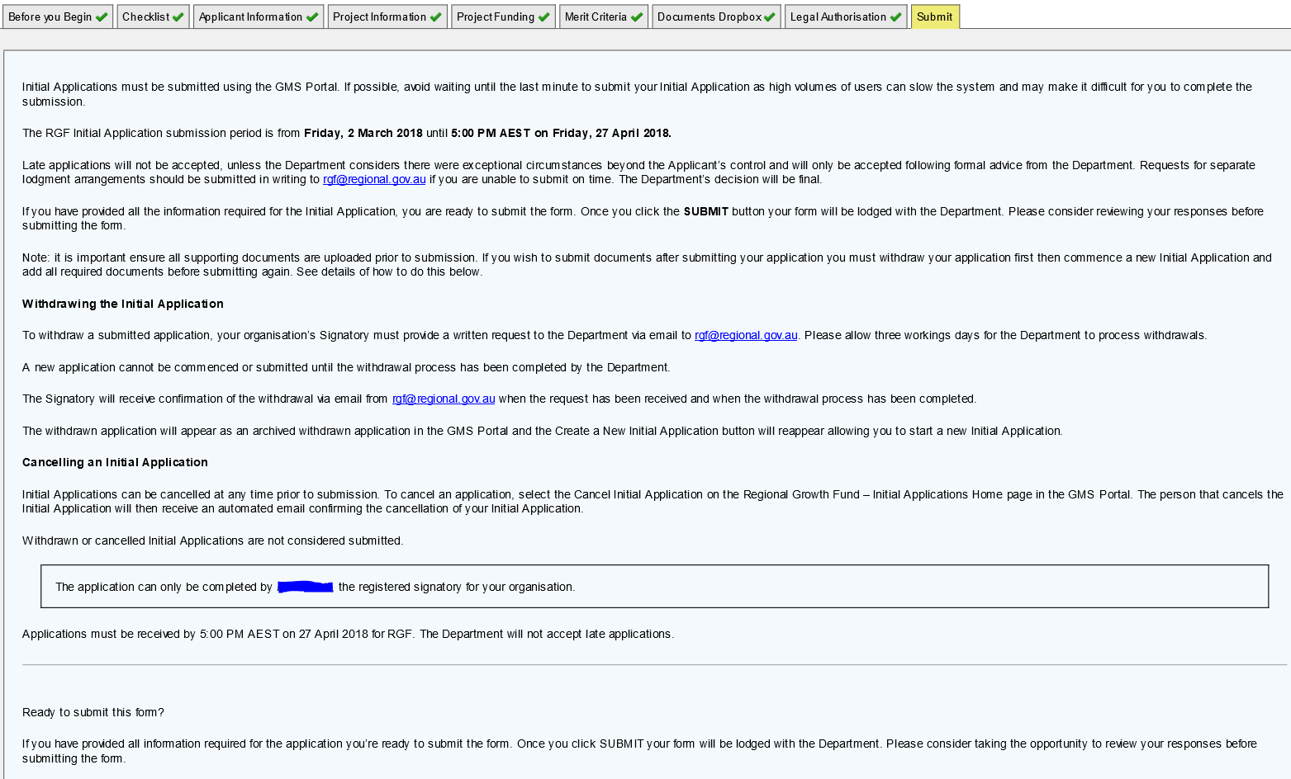

Returning to a saved Initial Application
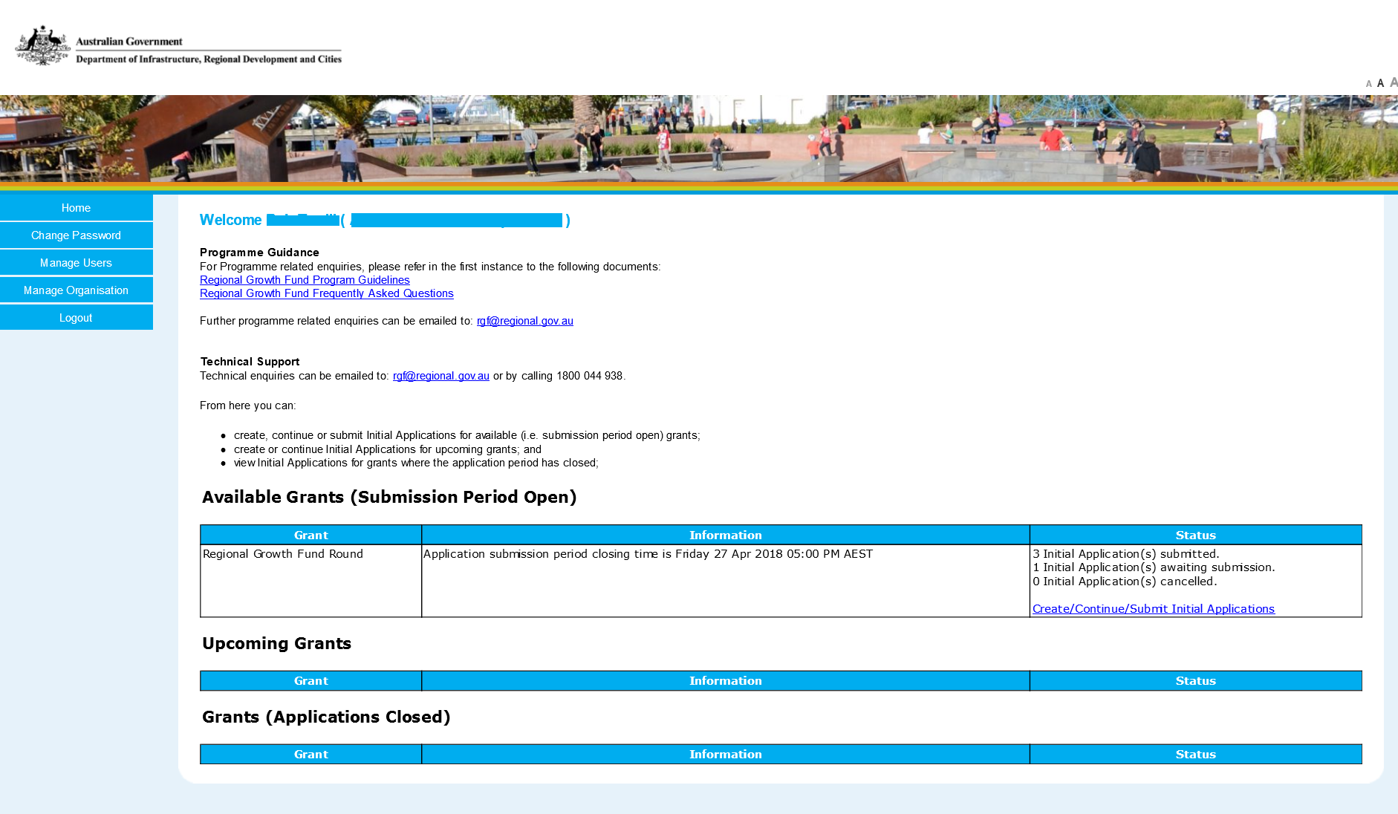
After logging back in, on the home page you will see status of Initial Applications submitted, awaiting submission, and cancelled. To continue working on an unsubmitted Application select “Create/Continue/Submit Initial Application”.
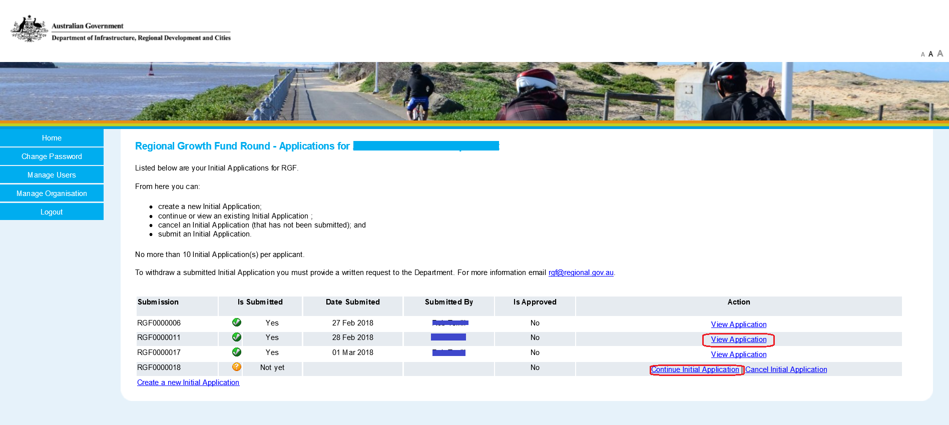
To continue with an un-submitted Initial Application select “Continue Initial Application” on the row corresponding the submission number. Already Submitted Initial Applications can be viewed from here also.

Submitting multiple Initial Applications
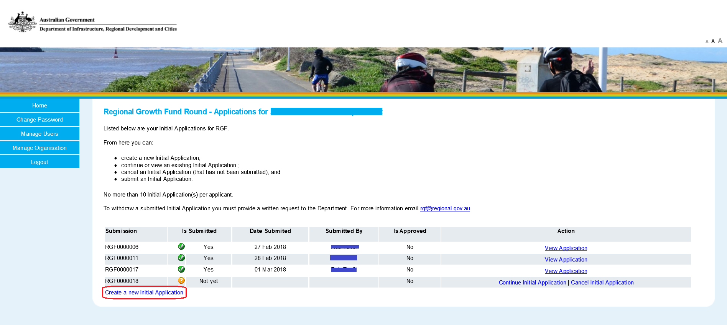
To submit multiple application follow the same process as above except select “Create a new Initial Application”.
The GMS will allow you to submit up to 10 separate Initial Applications. If you intend on submitting more than that, please contact the RGF help desk, providing a minimum of three days-notice from the Initial Application closing date.
Contact – For Assistance contact RGF help at rgf@regional.gov.au or by phone on 1800 044 938

